AIM
To simulate a cloud computing scenario by replacing the default CloudSim broker with a custom Shortest Job First (SJF) scheduling algorithm, thereby understanding how CloudSim can be extended to implement custom resource management and scheduling strategies.

PROBLEM STATEMENT
In CloudSim, the Datacenter Broker acts as an intermediary between users and cloud resources. The broker manages cloudlets, assigns them to virtual machines, and handles scheduling decisions. The default scheduling behavior does not consider the execution length of individual tasks.
In this experiment, a custom SJFDatacenterBroker is implemented by extending the CloudSim DatacenterBroker. The custom broker sorts the submitted cloudlets according to their execution length and schedules the shortest task first.
- Create a CloudSim datacenter.
- Create a virtual machine.
- Create cloudlets with different execution lengths.
- Implement a custom SJF broker.
- Sort cloudlets based on their execution length.
- Run the CloudSim simulation.
- Observe and verify the execution order of the cloudlets.

CLOUDSIM
CloudSim is a simulation framework that enables researchers and developers to model and experiment with cloud computing environments without requiring actual large-scale cloud infrastructure.
It can be used to simulate datacenters, virtual machines, cloudlets, resource allocation and scheduling policies. In this experiment, the main components are the Virtual Machine, Cloudlet and Datacenter Broker.

SHORTEST JOB FIRST SCHEDULING
Shortest Job First is a scheduling technique in which the task having the smallest execution time is selected before longer tasks. In this experiment, the cloudlets are sorted in ascending order of their execution length.
Cloudlet 0 → 40000 MI
Cloudlet 1 → 10000 MI
Cloudlet 2 → 20000 MI
SJF order:
Cloudlet 1 → Cloudlet 2 → Cloudlet 0

PROCEDURE

Step 1: Install the Required Software
The required Java development environment, Git and Maven were installed in Ubuntu.
sudo apt update
sudo apt install default-jdk git maven -y
The installations were verified using:
java -version
mvn -version
git –version
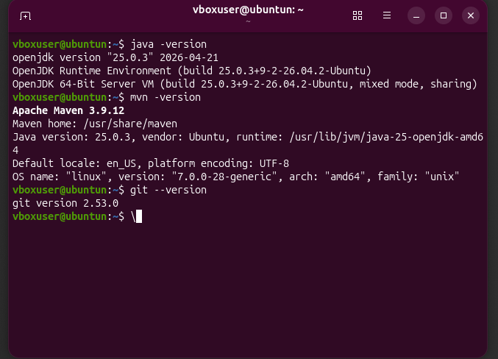

Step 2: Configure Java Environment
Java 21 was selected as the active Java version for the CloudSim project. The Java runtime and compiler configurations were checked using the update-alternatives command.
sudo update-alternatives --config java
sudo update-alternatives --config javac
java -version
javac -version
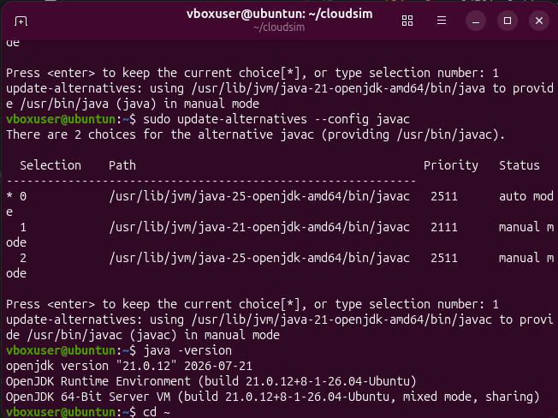

Step 3: Clone the CloudSim Repository
The official CloudSim repository was cloned using Git.
cd ~
git clone https://github.com/Cloudslab/cloudsim.git
cd cloudsim
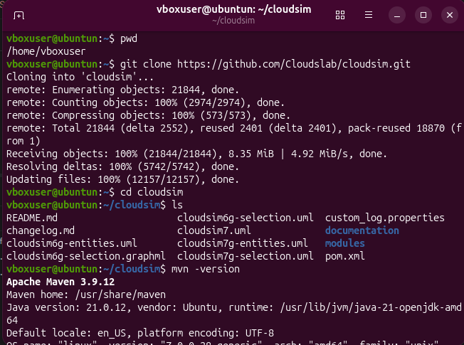

Step 4: Build the CloudSim Project
The CloudSim project was compiled and its dependencies were installed using Maven.
mvn clean install
The build completed successfully with the CloudSim modules reporting SUCCESS and BUILD SUCCESS.

Step 5: Import CloudSim into IntelliJ IDEA
The cloned CloudSim directory was opened in IntelliJ IDEA as a Maven project. IntelliJ loaded the project structure and required dependencies.
/home/vboxuser/cloudsim
The relevant project path used for the experiment was:
cloudsim
└── modules
└── cloudsim-examples
└── src
└── main
└── java
└── org.cloudbus.cloudsim.examples
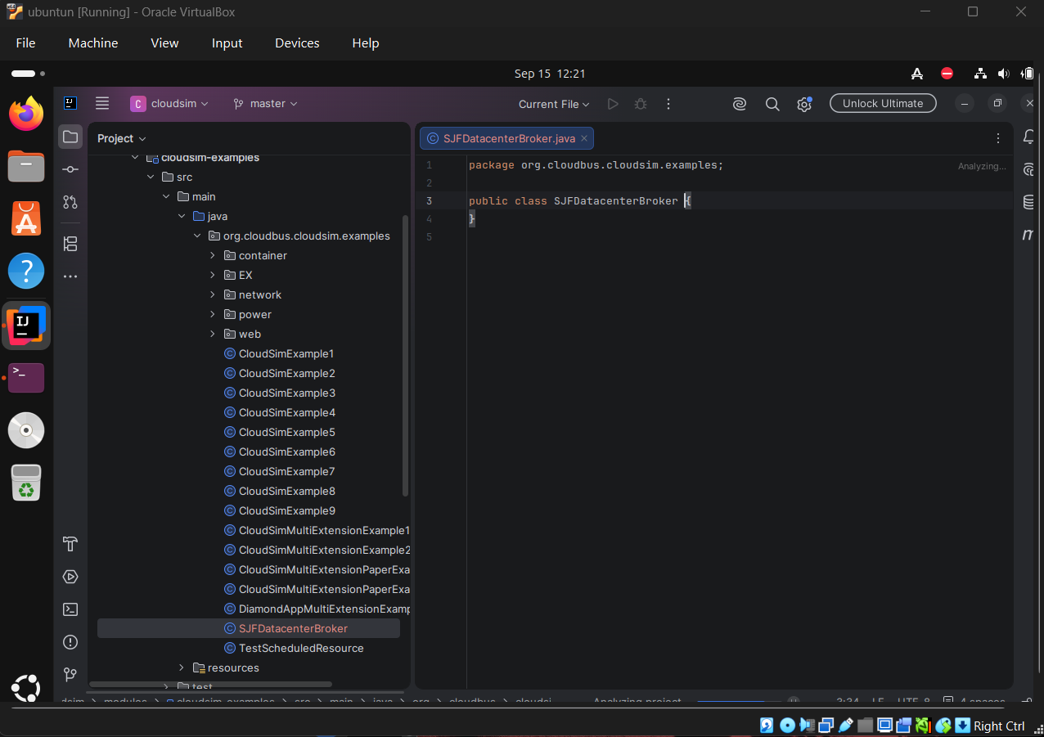

Step 6: Create the Custom SJF Broker
A new Java class named SJFDatacenterBroker.java was created inside the org.cloudbus.cloudsim.examples package. The class extends the CloudSim DatacenterBroker class and overrides submitCloudlets() to sort cloudlets according to their execution length.
Collections.sort(
getCloudletList(),
new Comparator<Cloudlet>() {
@Override
public int compare(Cloudlet c1, Cloudlet c2) {
return Long.compare(
c1.getCloudletLength(),
c2.getCloudletLength()
);
}
}
);
super.submitCloudlets();

Step 7: Create the Main Simulation Class
A new Java class named SJFSimulation.java was created in the same package. The main simulation initializes CloudSim, creates the datacenter and broker, creates the virtual machine and cloudlets, starts the simulation, retrieves the results and prints the output.
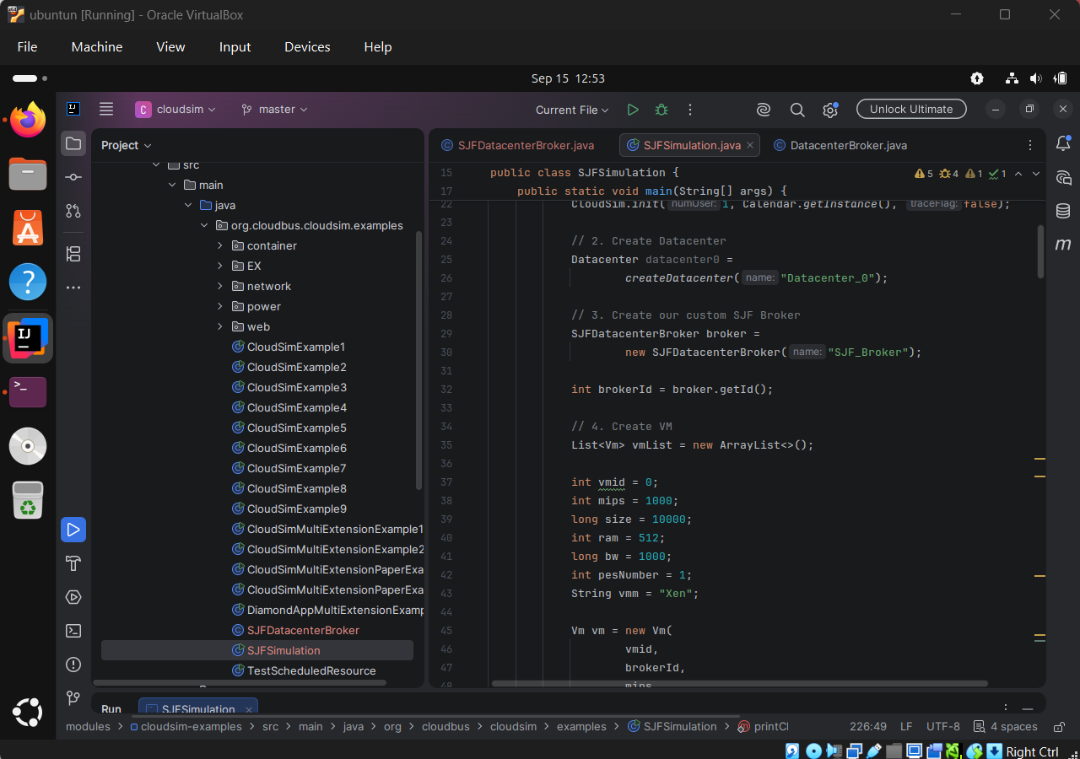

Step 8: Create Cloudlets
Three cloudlets with different execution lengths were created:
Cloudlet ID | Execution Length
Cloudlet 0 | 40,000 MI
Cloudlet 1 | 10,000 MI
Cloudlet 2 | 20,000 MI
The cloudlets were intentionally added in the order Cloudlet 0, Cloudlet 1 and Cloudlet 2.

Step 9: Apply SJF Scheduling
The custom broker examined the execution length of each pending cloudlet and sorted them in ascending order.
Before sorting:
Cloudlet 0 → 40000 MI
Cloudlet 1 → 10000 MI
Cloudlet 2 → 20000 MI
After SJF sorting:
Cloudlet 1 → 10000 MI
Cloudlet 2 → 20000 MI
Cloudlet 0 → 40000 MI

Step 10: Run the Simulation
The SJFSimulation.java class was executed from IntelliJ IDEA using the Run SJFSimulation.main() option. The console output was examined to verify the execution order.
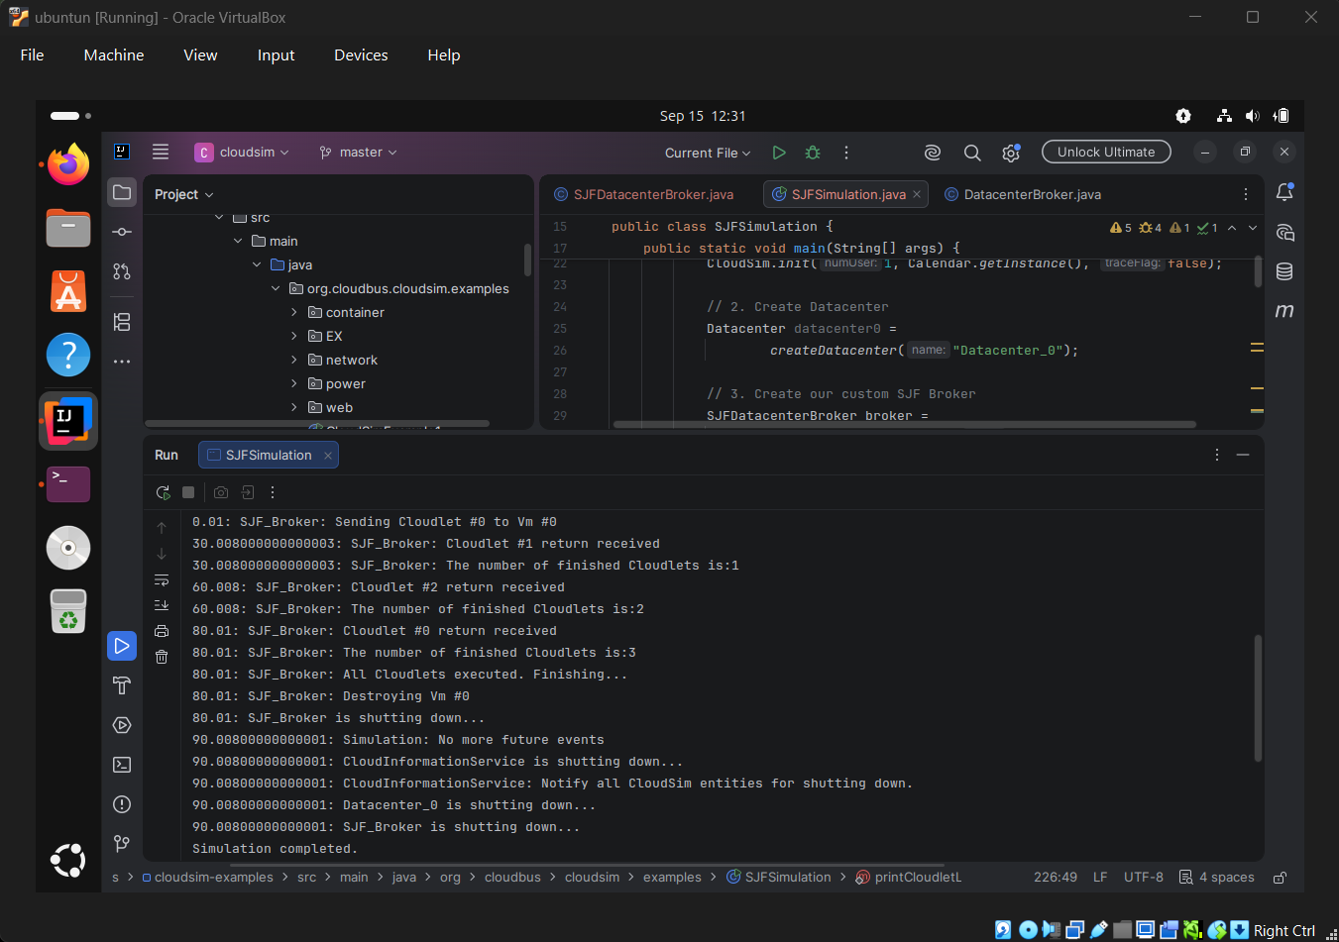

OUTPUT
The following output was obtained from the simulation:
========== SJF SIMULATION RESULTS ==========
Cloudlet ID | Length | Status | VM ID | Start | Finish
1 | 10000 | SUCCESS | 0 | 0.01 | 30.01
2 | 20000 | SUCCESS | 0 | 0.01 | 60.01
0 | 40000 | SUCCESS | 0 | 0.01 | 80.01
Expected SJF order: Cloudlet 1 → Cloudlet 2 → Cloudlet 0
Process finished with exit code 0
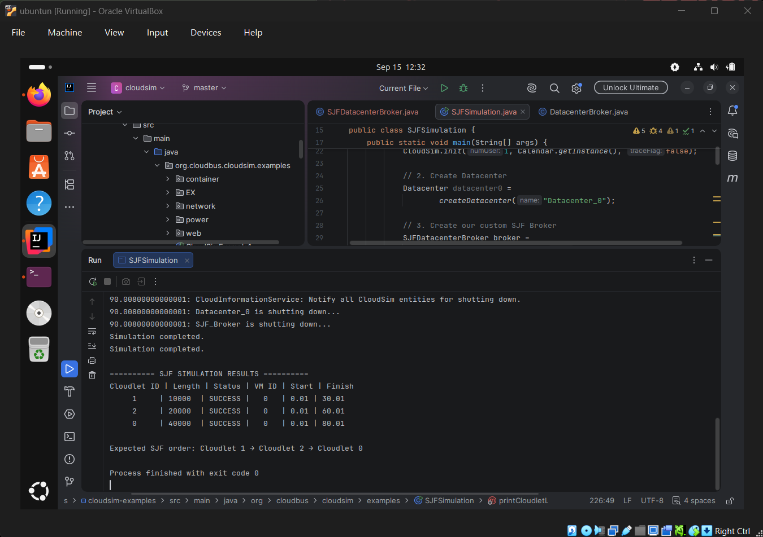

RESULT
Thus, a custom Shortest Job First (SJF) scheduling algorithm was successfully implemented in CloudSim by extending the DatacenterBroker and modifying the cloudlet submission process.
The simulation successfully executed all three cloudlets, with the completion order:
Cloudlet 1 → Cloudlet 2 → Cloudlet 0
The results confirm that the shortest cloudlet was completed first, followed by the medium and longest cloudlets. Hence, the Shortest Job First scheduling logic was successfully implemented and verified.

CONCLUSION
The experiment demonstrated the implementation of a custom scheduling policy in CloudSim. A custom SJFDatacenterBroker was developed to sort cloudlets based on their execution length before submission.
The successful execution of Cloudlet 1, Cloudlet 2 and Cloudlet 0 in increasing order of their lengths verified the correctness of the SJF scheduling algorithm. The experiment also demonstrated how CloudSim can be extended to develop and evaluate different scheduling and resource-management strategies in a simulated cloud environment.

